The Moon
Time Limit: 2000/1000 MS (Java/Others) Memory Limit: 262144/262144 K (Java/Others)
Total Submission(s): 966 Accepted Submission(s): 435
Special Judge
Problem Description
The Moon card shows a large, full moon in the night’s sky, positioned between two large towers. The Moon is a symbol of intuition, dreams, and the unconscious. The light of the moon is dim, compared to the sun, and only vaguely illuminates the path to higher consciousness which winds between the two towers.
Random Six is a FPS game made by VBI(Various Bug Institution). There is a gift named "Beta Pack". Mr. K wants to get a beta pack. Here is the rule.
Step 0. Let initial chance rate q = 2%.
Step 1. Player plays a round of the game with winning rate p.
Step 2. If the player wins, then will go to Step 3 else go to Step 4.
Step 3. Player gets a beta pack with probability q. If he doesn’t get it, let q = min(100%, q + 2%) and he will go to Step 1.
Step 4. Let q = min(100%, q + 1.5%) and goto Step 1.
Mr. K has winning rate p% , he wants to know what’s the expected number of rounds before he needs to play.

Input
The first line contains testcase number T (T ≤ 100). For each testcase the first line contains an integer p (1 ≤ p ≤ 100).

Output
For each testcase print Case i : and then print the answer in one line, with absolute or relative error not exceeding 106.

Sample Input
2
50
100

Sample Output
Case 1: 12.9933758002
Case 2: 8.5431270393

Source
2018CCPC吉林赛区（重现赛）- 感谢北华大学

Recommend
chendu | We have carefully selected several similar problems for you: 6742 6741 6740 6739 6738

要补题对我这种技能树小的选手来说真的很难啊。。
Dp基本放弃了的。。唉
题意：

Step 0. Let initial chance rate q = 2%.
Step 1. Player plays a round of the game with winning rate p%.
Step 2. If the player wins, then will go to Step 3 else go to Step 4.
Step 3. Player gets a beta pack with probability q. If he doesn't get it, let q = min(100%, q + 2%) and he will go to Step 1.
Step 4. Let q = min(100%, q + 1.5%) and goto Step 1.
Mr. K has winning rate p% , he wants to know what's the expected number of rounds before he needs to play.

题解：dp[i][j]表示 q为i，p为j时的期望次数，因为有一个1.5的存在，所以我们的q都乘10进行计算

dp[q][p]=1+1.0*p/100*(1-1.0*q/1000)*dp[min(q+20,1000)][p]+(100.0-p)/100*dp[min(q+15,1000)][p]

初始dp[1000][i]=100/i
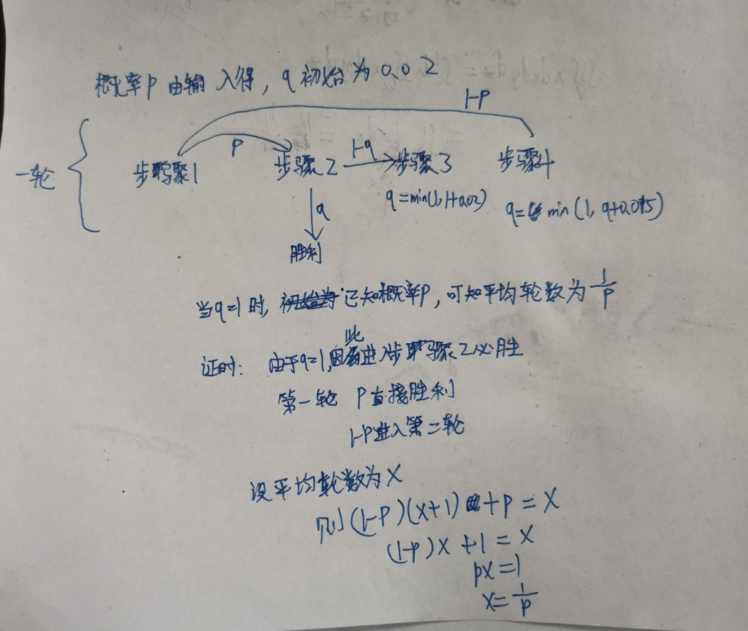
这是超哥的证明

#include<map>
#include<set>
#include<cmath>
#include<queue>
#include<stack>
#include<cstdio>
#include<vector>
#include<bitset>
#include<string>
#include<cstdlib>
#include<cstring>
#include<fstream>
#include<sstream>
#include<iomanip>
#include<iostream>
#include<algorithm>
#include<functional>
//#include<bits/stdc++.h>
#define INF 0x3f3f3f3f //1061109567
#define llINF 9223372036854775807
#define pi 3.141592653589793
#define ll long long
using namespace std;
const ll maxn=1e3+7;
const double eps=1e-10;
const ll mod=1e9+7;
/*
因为有一个1.5存在，q都乘以10
q为1的时候.平均轮数为1/p
dp[q][p]=1+1.0*p/100*(1-1.0*q/1000)*dp[min(q+20,1000)][p]+(100.0-p)/100*dp[min(q+15,1000)][p]
*/
double dp[1006][110];
double dfs(int q,int p)
{
if(dp[q][p]!=-1) return dp[q][p];
dp[q][p]=1+1.0*p/100*(1-1.0*q/(double)1000.0)*dfs(min(q+20,1000),p)+(100.0-p)/100*dfs(min(q+15,1000),p);
return dp[q][p];
}

int main()
{ for(int i=0;i<=1000;i++)
{
for(int j=1;j<=100;j++)
dp[i][j]=-1;
}
for(int i=1;i<=100;i++)
dp[1000][i]=100.0/i;
int t;
scanf("%d",&t);
for(int kk=1;kk<=t;kk++)
{
int p;
scanf("%d",&p);
printf("Case %d: %.10f\n",kk,dfs(20,p));
}
return 0;
}

